**Secure Data Sharing for Life-Saving Drugs in the Medical Domain**

**Problem Statement:**

In the fast-paced world of healthcare, where timely access to critical information can save lives, **MediCore Pharmaceuticals** faces the challenge of securely sharing sensitive data on life-saving drugs with authorized medical professionals. The company needs a solution to provide secure, temporary access to their life-saving drug data, ensuring that only authorized individuals, such as doctors and pharmacists, can download and review the files. With the sensitive nature of this data, it is essential to prevent unauthorized access while allowing flexibility for controlled sharing. To address this, MediCore Pharmaceuticals plans to use Amazon S3 to generate presigned URLs, enabling temporary, secure access to the drug information without exposing it to the public. This approach ensures that the company can efficiently share critical drug data while maintaining strict security standards, ultimately supporting better patient care and timely decision-making in emergency situations.



**Pre-requisites:**

### 1. AWS Account Setup: [https://youtu.be/CjKhQoYeR4Q?si=ui8Bvk_M4FfVM-D](https://youtu.be/CjKhQoYeR4Q?si=ui8Bvk_M4FfVM-Dh)h

### 2. Understanding of IAM: <https://youtu.be/gsgdAyGhV0o?si=3qg-bULgkD4LXNvR>

### 3. Basic Knowledge of Amazon S3: <https://youtu.be/bktTomENEX8?si=dsJImPcPJrZY50CE>

**Objective:**

The objective of this project is to implement a secure file-sharing solution for MediCore Pharmaceuticals to manage and distribute sensitive life-saving drug data. By leveraging Amazon S3 and presigned URLs, the company aims to provide temporary, controlled access to authorized medical professionals, ensuring that only approved users can view or download the data. This solution will enhance security, prevent unauthorized access, and ensure that critical drug information is available when needed for timely decision-making in healthcare.

**Tasks:**

1. Log in to AWS Management Console
2. Create an S3 Bucket
3. Upload Excel Files
4. Copy the object url and test the object url
5. Generate Presigned URLs using AWS Management Console
6. Test the Generated URLs

**Solution Development Procedure:**

1. Log in to the AWS Management Console and navigate to the S3 service.

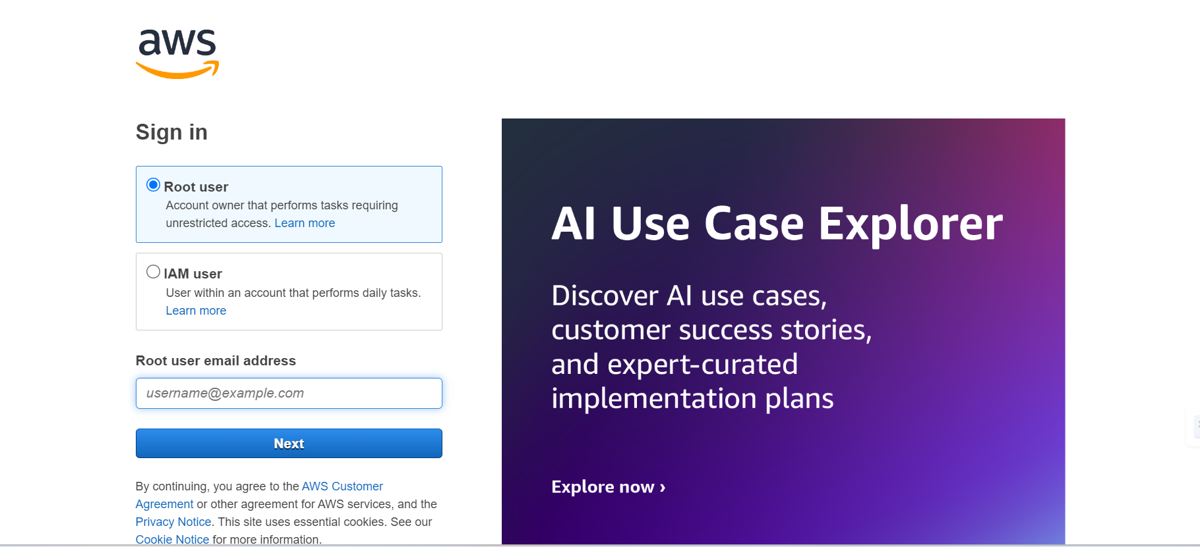

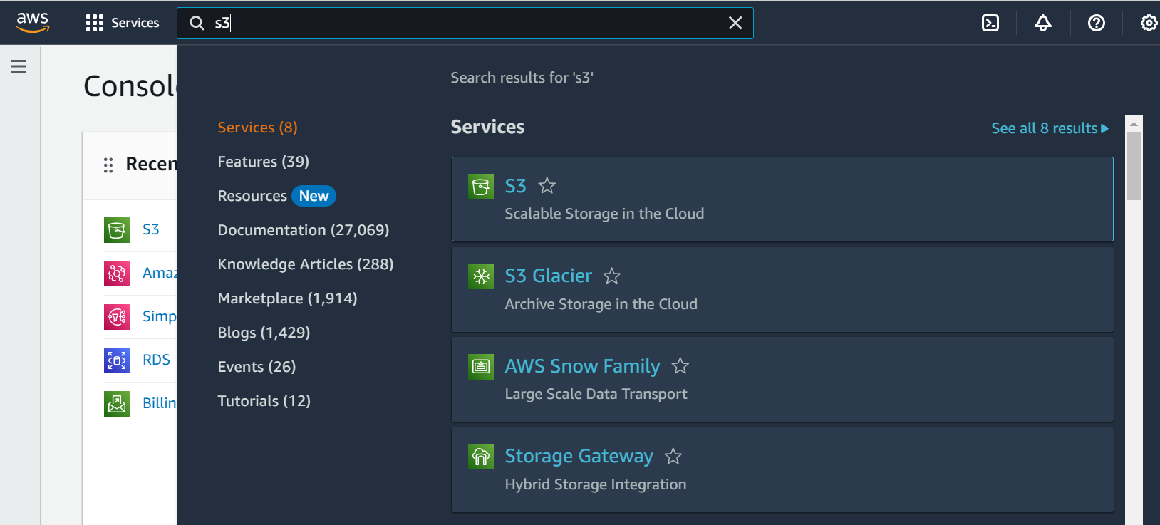

1. Create an S3 bucket

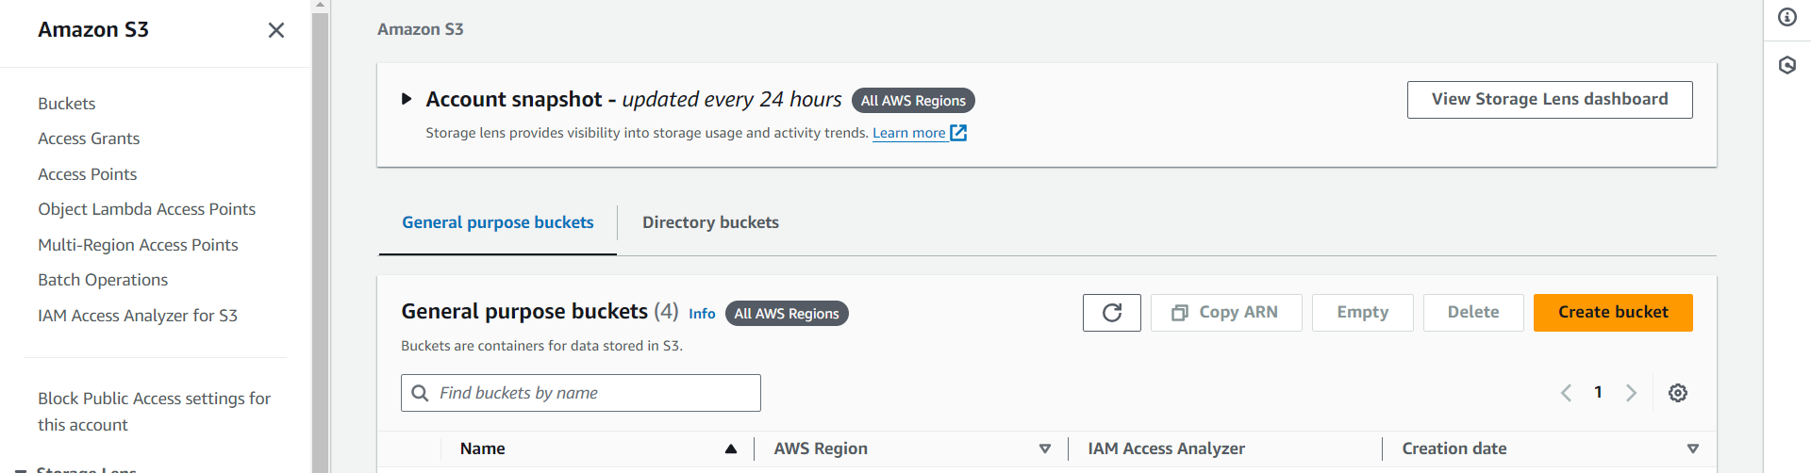

* Click on Create bucket to create a bucket to store the medical drugs data.

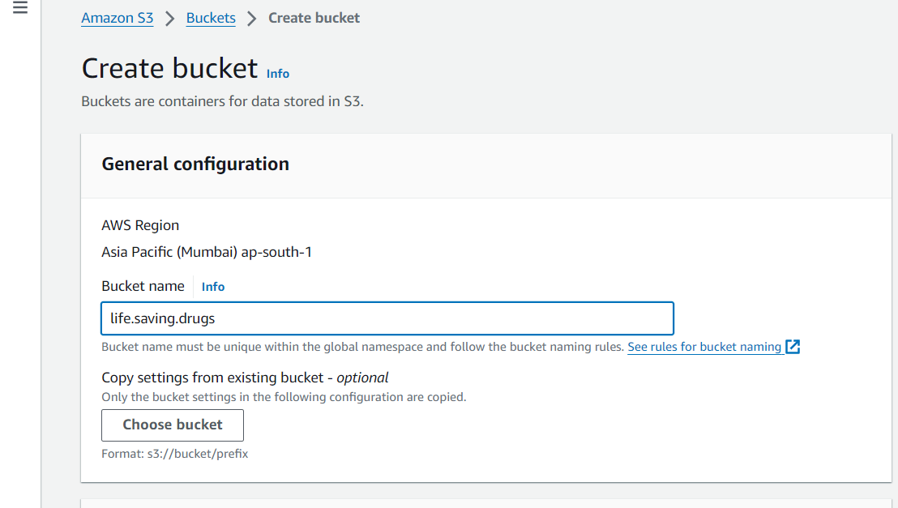

* And give an Bucket name

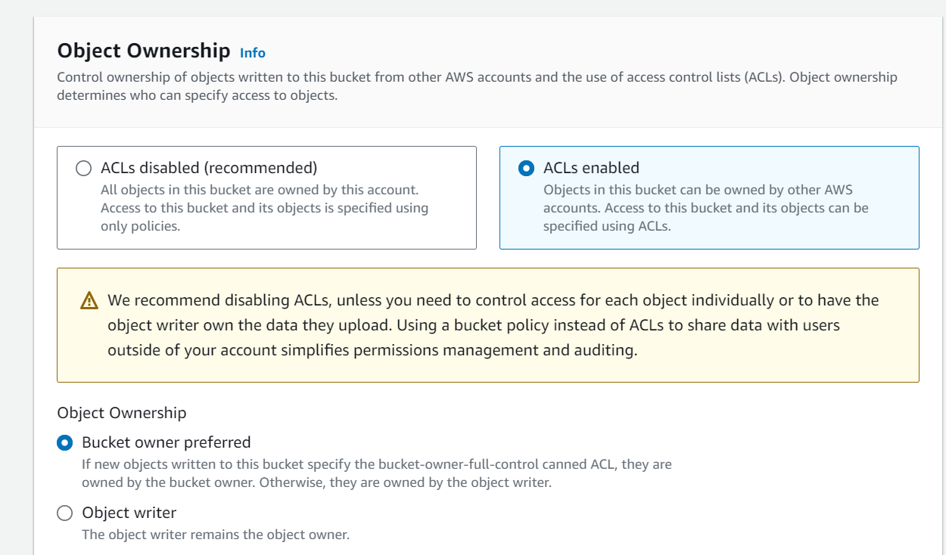

* Enable ACLs Ownership

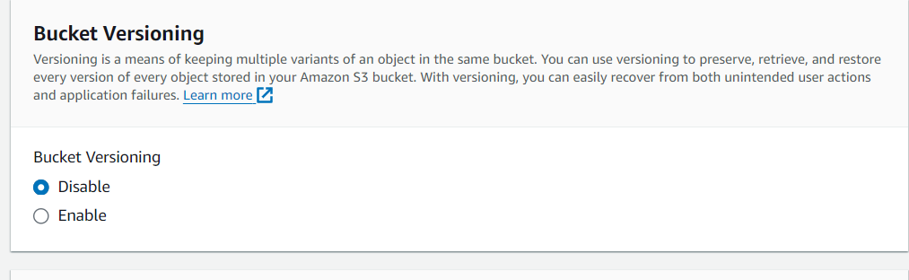

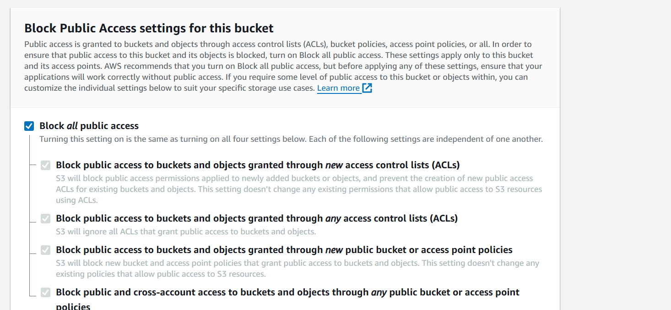

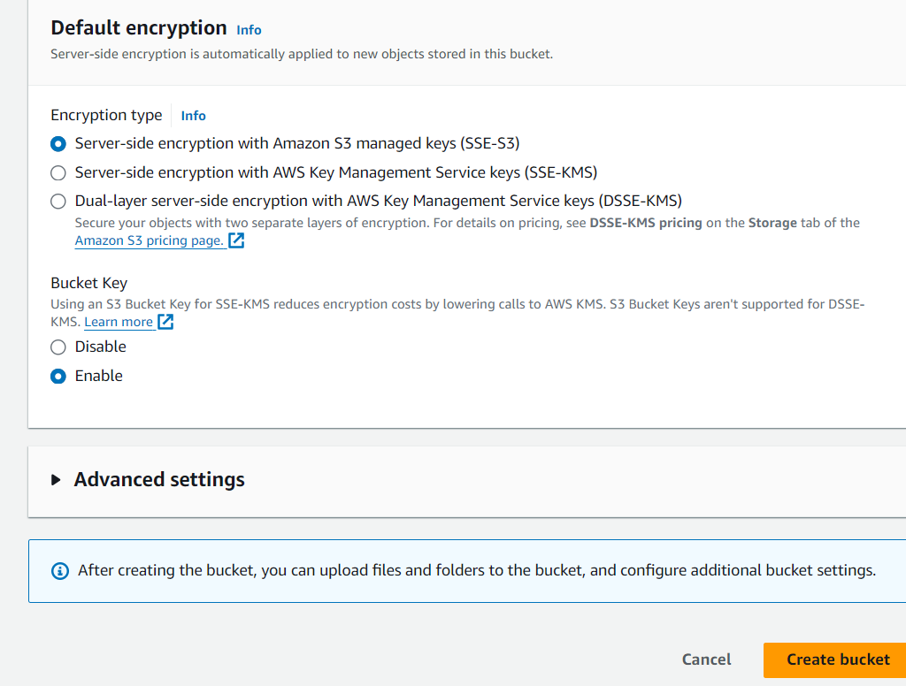

* Click on Create bucket.

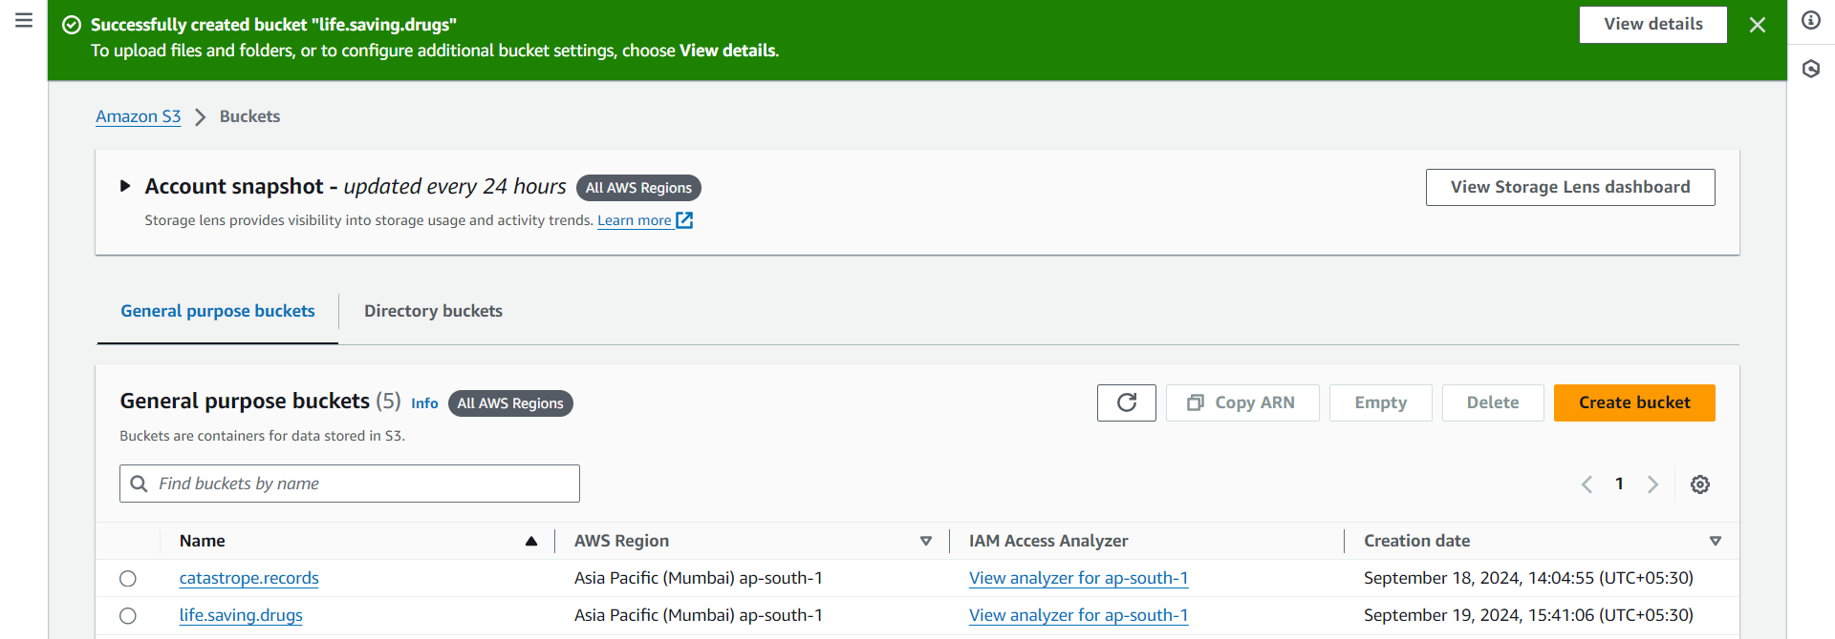

* Bucket is successfully created , Now click on the life.saving.drugs

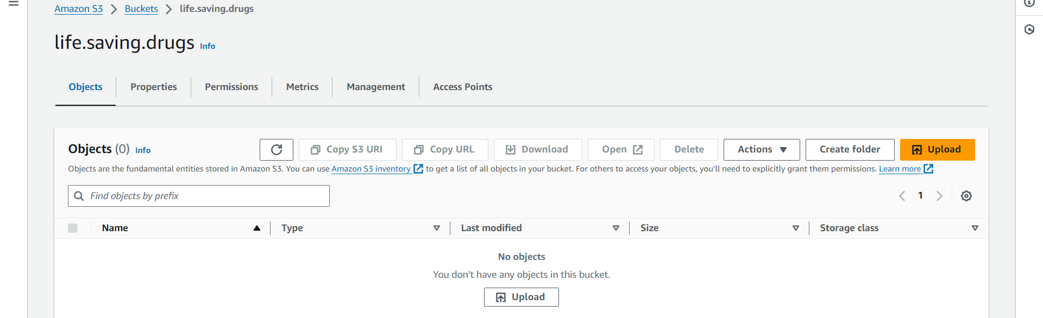

* Click on the Upload Button to upload the data

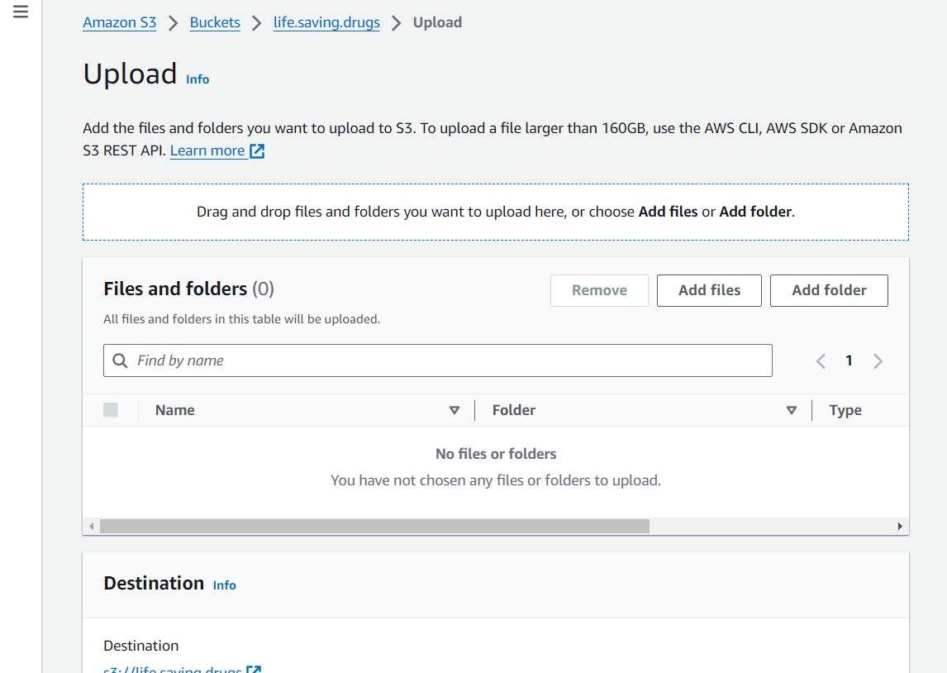

* Here , drag the file from storage or click on Add files

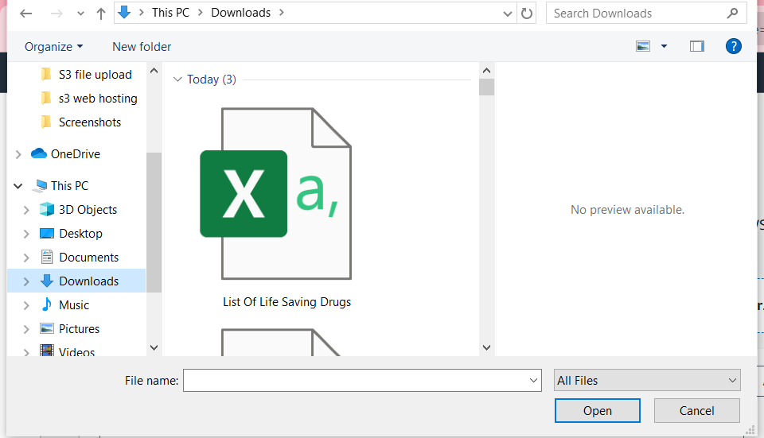

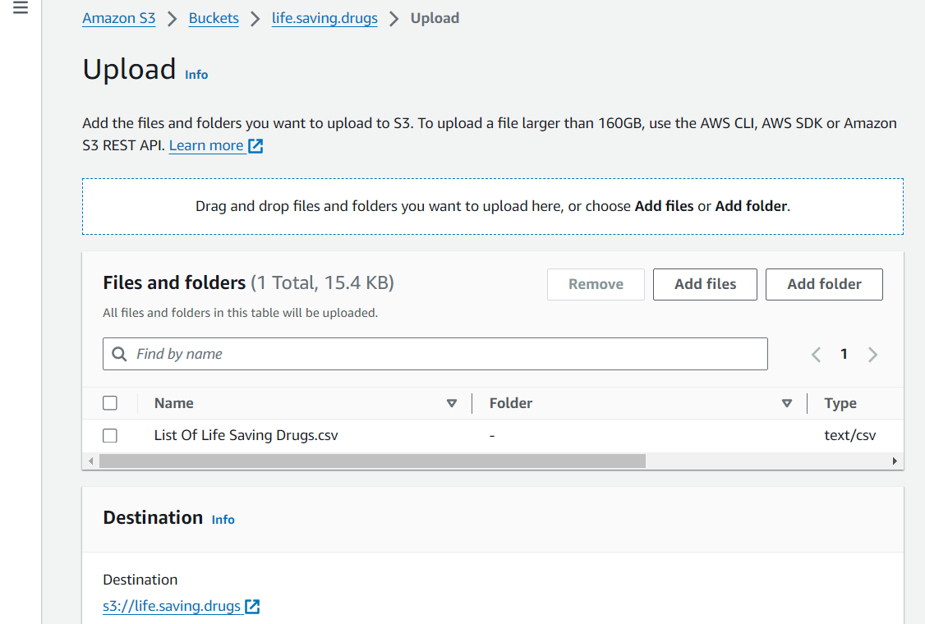

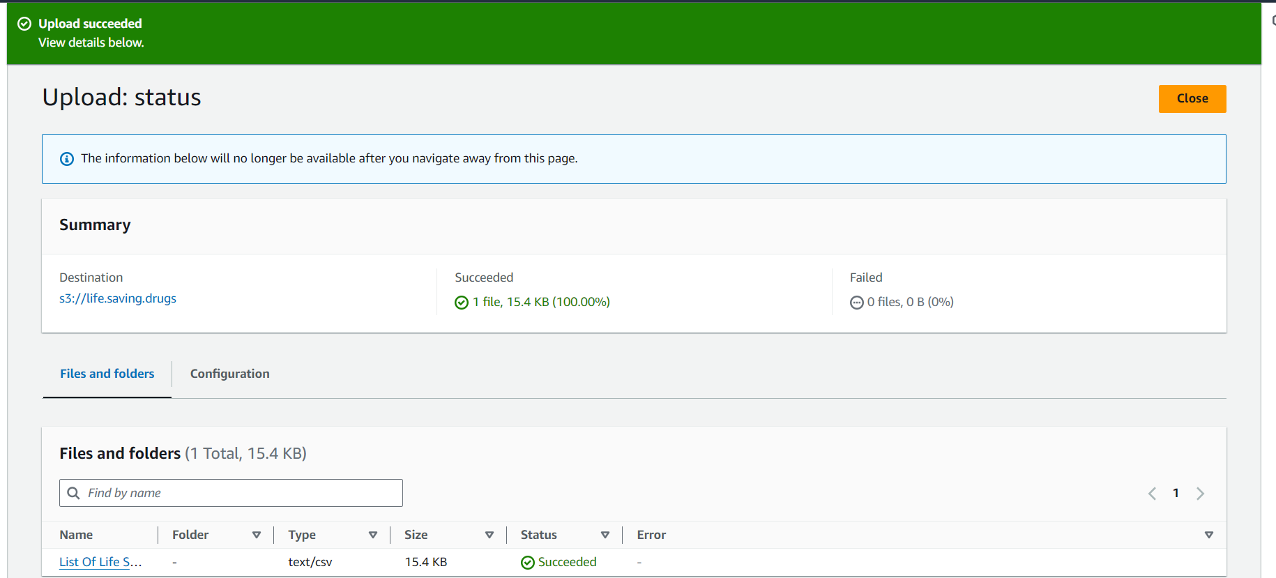

* We have successfully loaded the data into the bucket.

1. Now click on file and Copy the object url

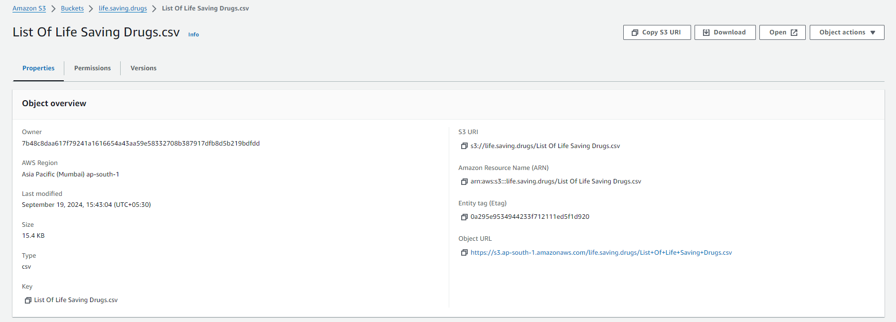

* Text the object url

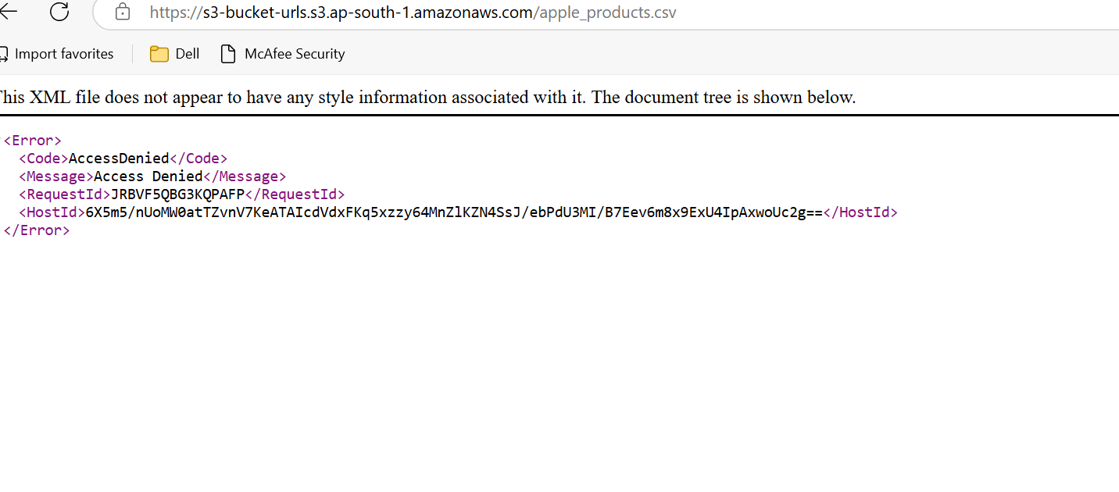

* As their is no access to the file , it gave an error message.

1. Generate presigned url

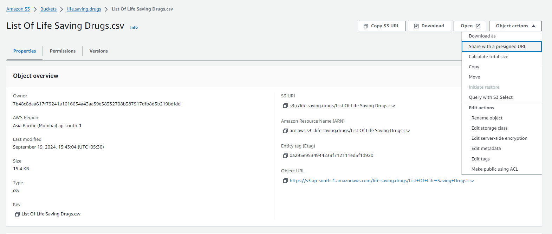

* Now click on file and click on the object actions
* Click on share with a presigned URL

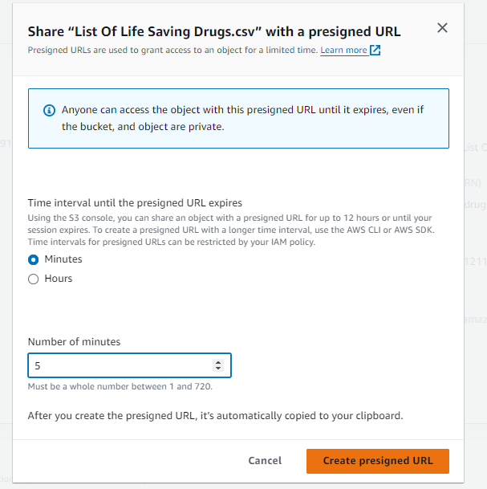

* Select the time interval until the presigned url expires and number of hours
* Create presigned url

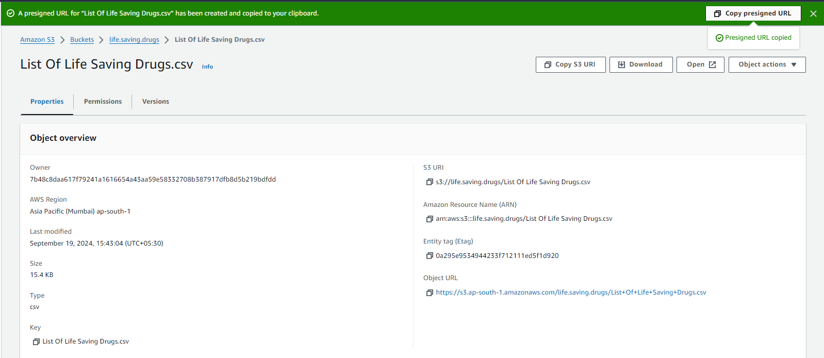

* Now, click on the copy presigned URL to copy the accessed url to open excel sheet.

1. Text the Presigned URL

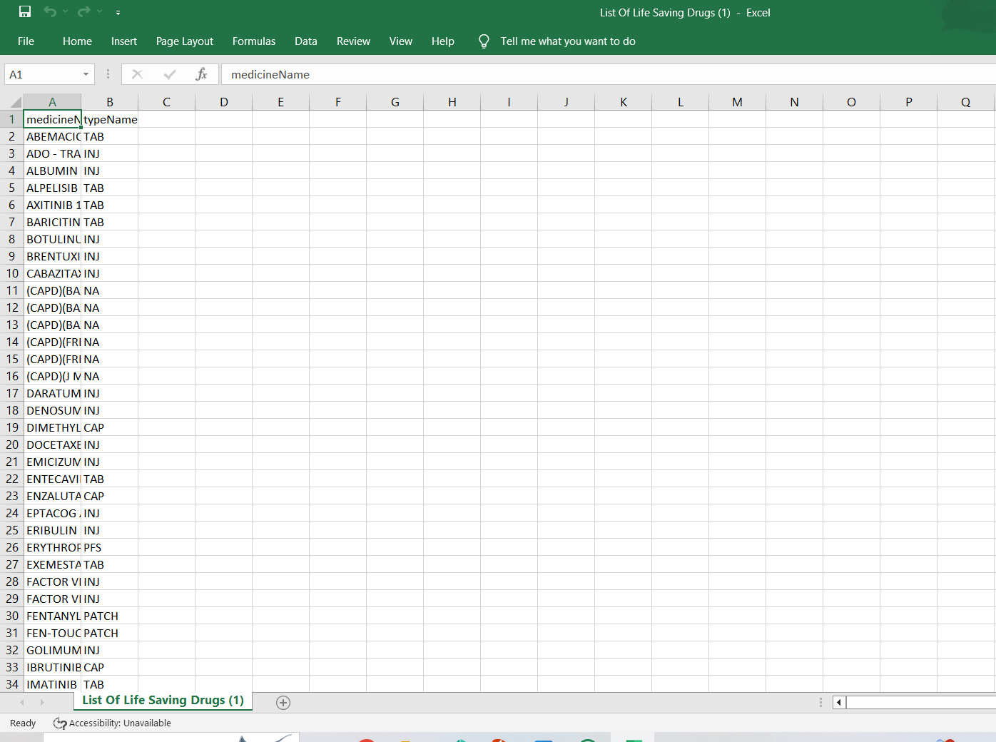

* **We have successfully created a secured url for our life saving drugs data.**

**Conclusion:**

By using Amazon S3 and pre-signed URLs, MediCore Pharmaceuticals can effectively secure and manage the sharing of life-saving drug data with authorized medical professionals. The implementation of temporary, controlled access links prevents unauthorized downloads while maintaining flexibility in distributing critical information. This solution not only enhances data security but also ensures that medical professionals can quickly access essential drug information, ultimately supporting better patient care and more informed decision-making in life-critical situations.